·Area Plot

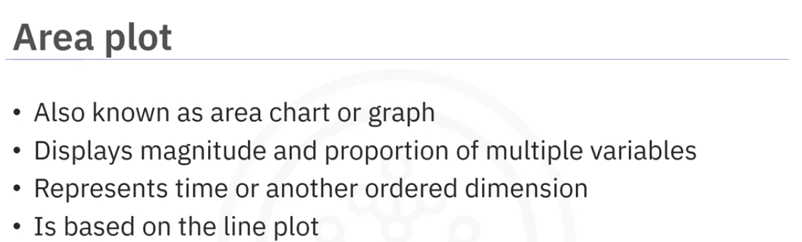

The area below the line is highlighted to emphasize the cumulative magnitude of the variables.

Used to compare 2 or more quantities.

Creating Area Plot:

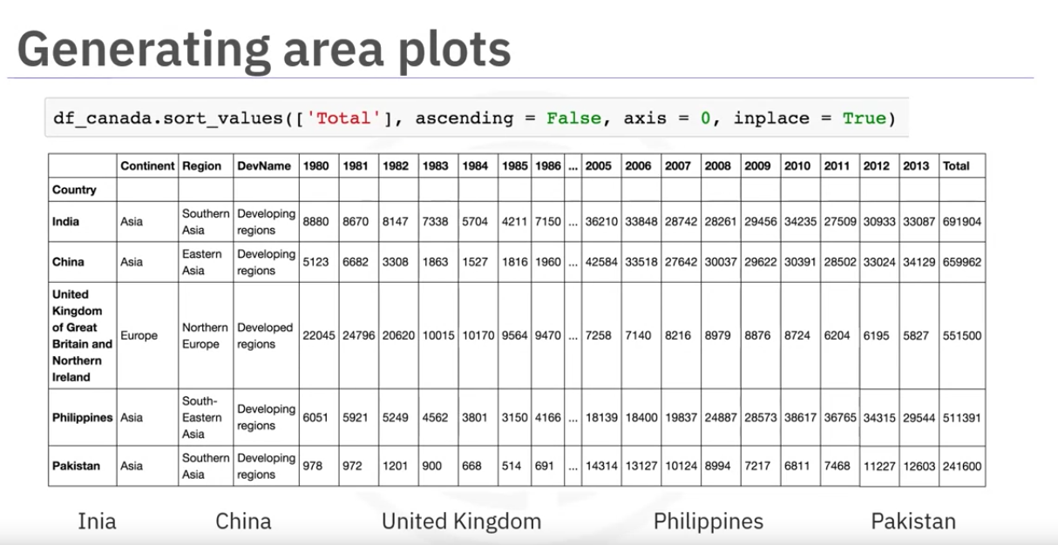

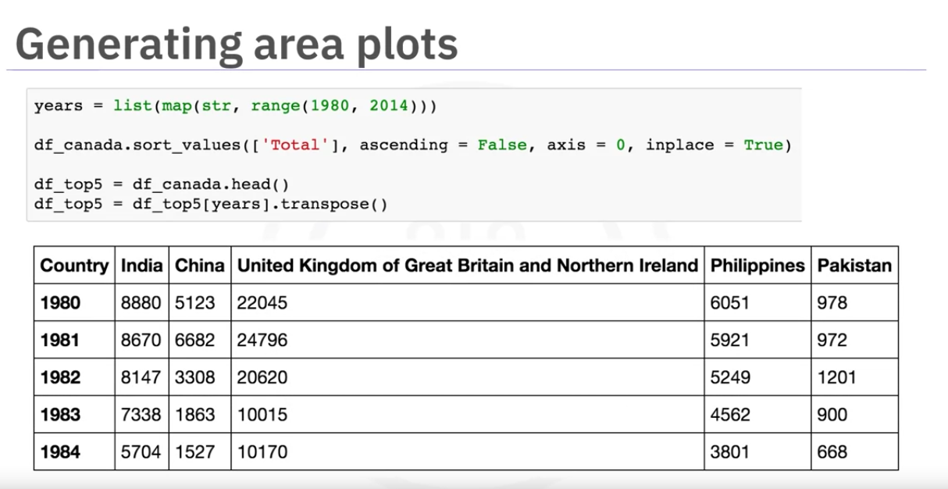

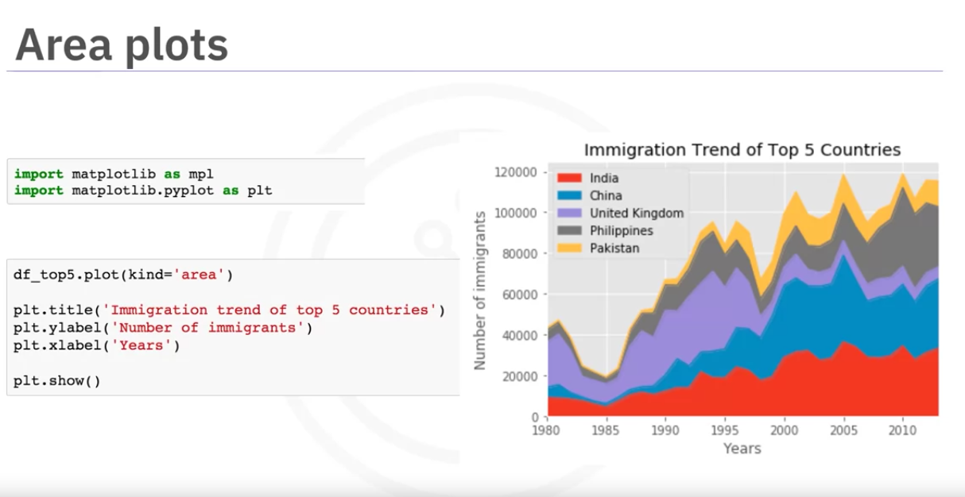

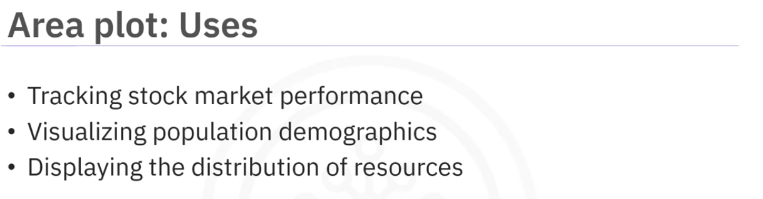

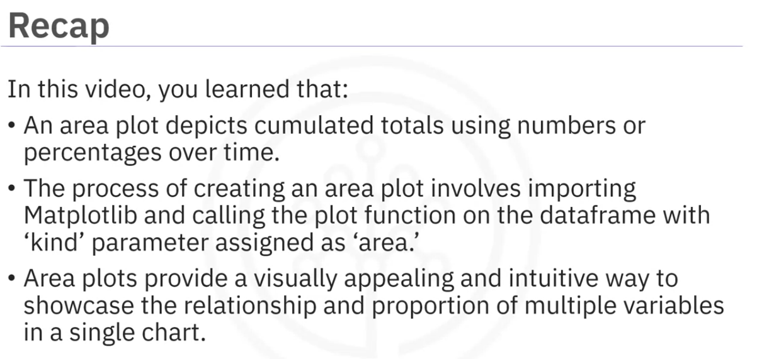

Histograms

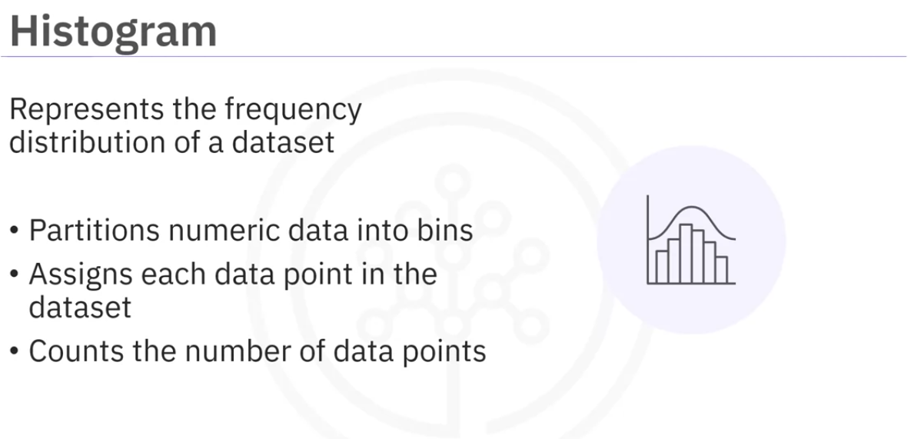

Verticle axis is always frequency.

splitting horizontal axis into bins.

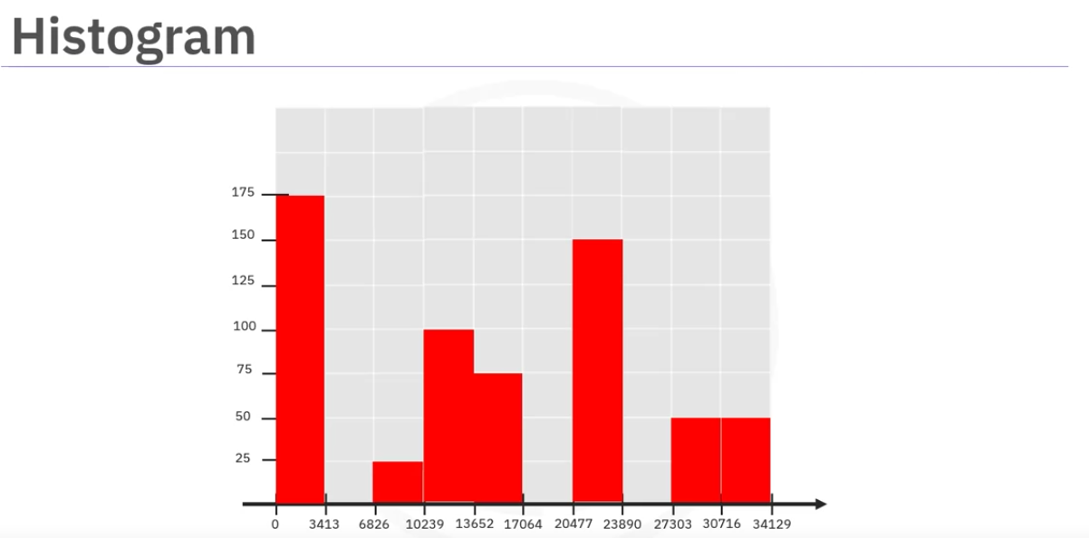

From data we only need country and total to display in the chart

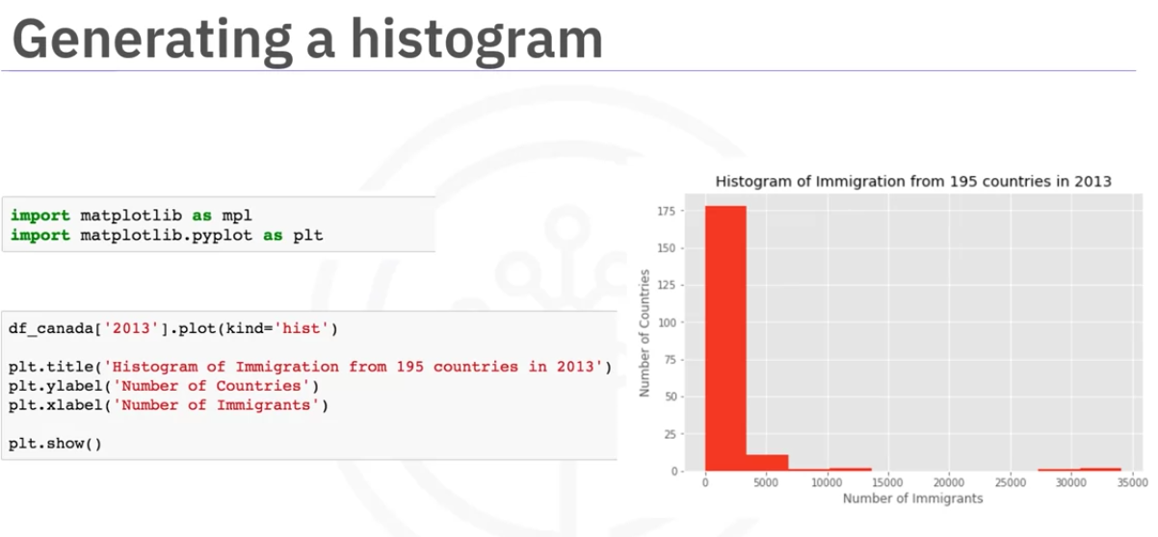

we can see in the above figure the nis are not aligned with the horizontal axis which will create confusion.

One way is to use histogram function from numpy which will split the data into 10 bins of equal width by default. It returns frequency of each bin which is sored in count and bin edges

we use the bin_edges as xticks

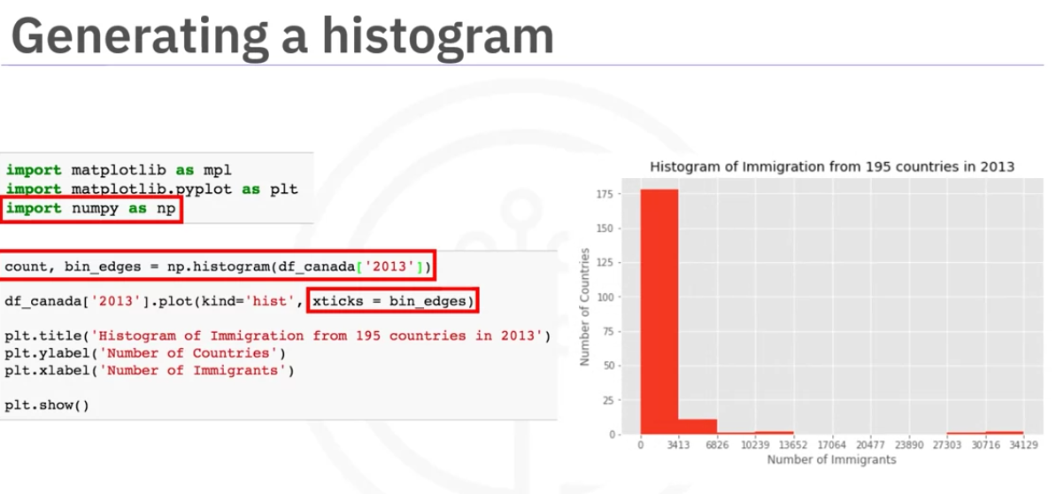

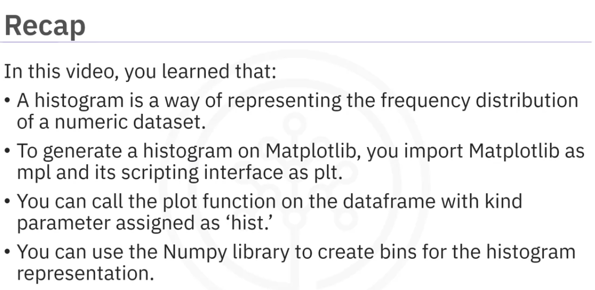

Bar Graph

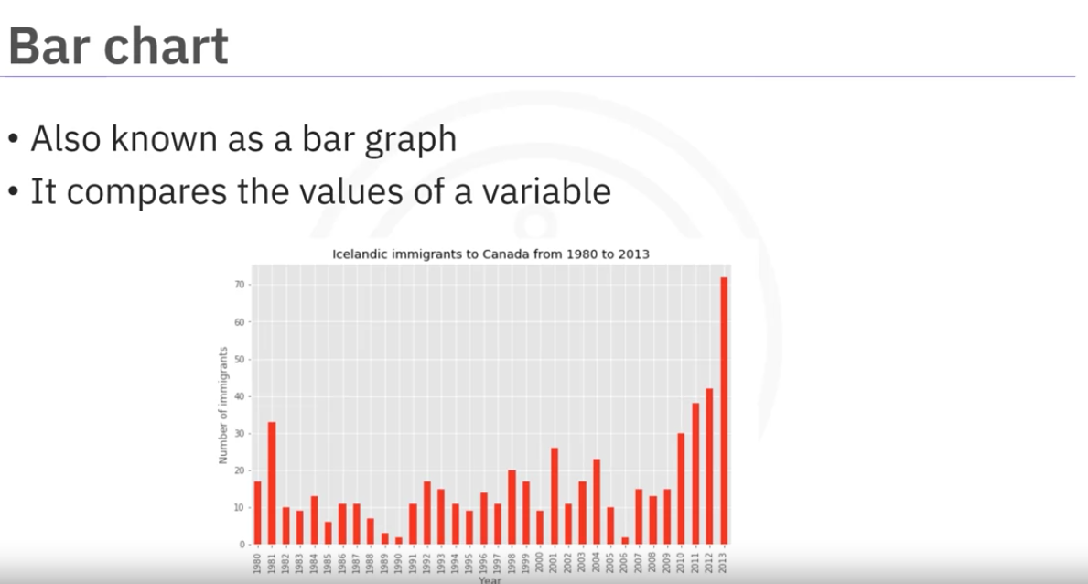

Barchat vs histogram

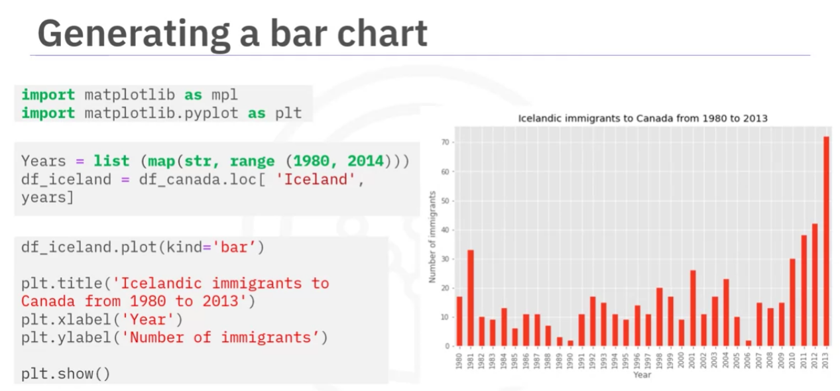

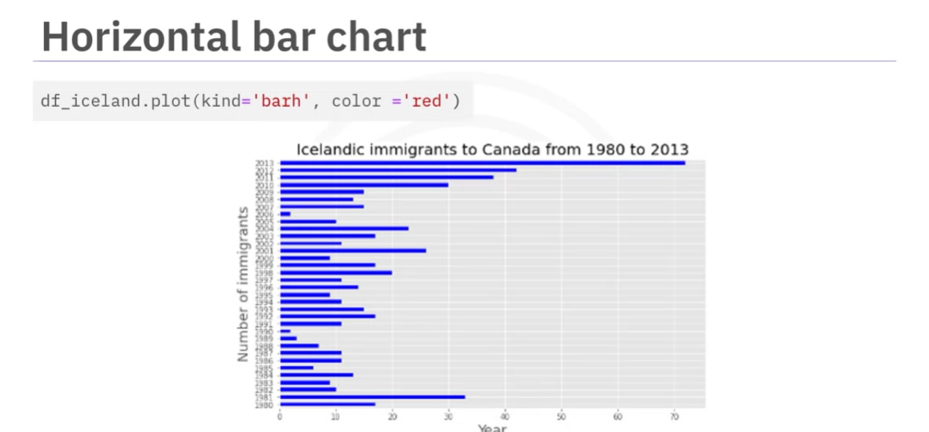

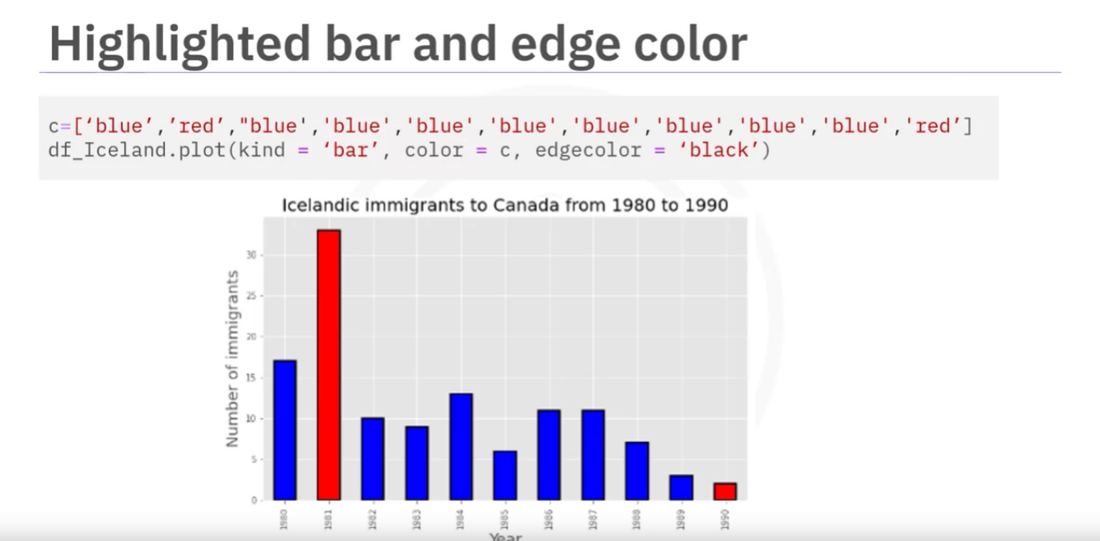

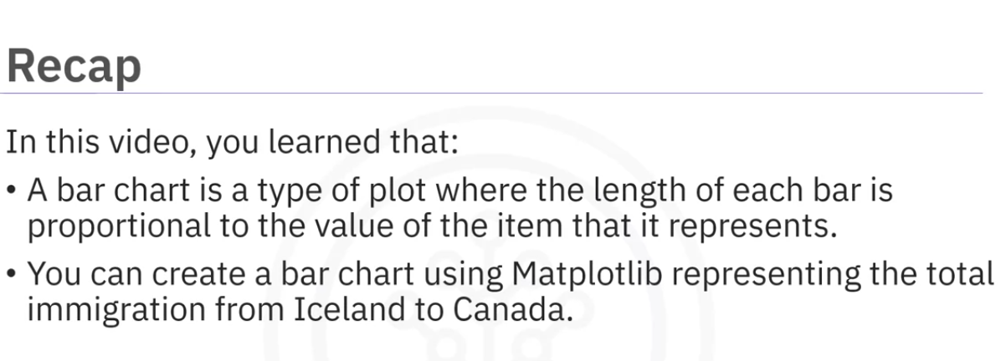

**Bar Chart vs. Histogram**:

Both bar charts and histograms display data using bars, but they serve different purposes and are used in distinct contexts.

### **Bar Chart**:

* **Purpose**: Used to display **categorical data**. Each bar represents a distinct category.
* **X-Axis**: Represents discrete categories or groups (e.g., types of fruits, countries, etc.).
* **Y-Axis**: Represents the count, frequency, or value associated with each category.
* **Spacing**: Bars are spaced apart because the categories are independent of each other.
* **Use Case**: When you want to compare different categories or groups (e.g., sales of different products, votes for candidates).

#### Example:

If you have data on the number of people who prefer different types of fruit (apples, bananas, oranges), you would use a bar chart.

### **Histogram**:

* **Purpose**: Used to display **continuous data** that has been divided into intervals (bins). Each bar represents the frequency of data within a specific range.
* **X-Axis**: Represents intervals or ranges of continuous data (e.g., ages, weights, time, etc.).
* **Y-Axis**: Represents the frequency or count of data points within each interval.
* **Spacing**: Bars are touching, as the data is continuous and the intervals are adjacent.
* **Use Case**: When you want to show the distribution of a continuous variable (e.g., distribution of heights, test scores).

#### Example:

If you have data on the ages of a group of people and want to see how that data is distributed (e.g., how many people are in the age range of 20–30, 30–40, etc.), a histogram is appropriate.

### **When to Use**:

* Use a **bar chart** when you are comparing **different categories** of data.
* Use a **histogram** when you are analyzing the **distribution of continuous data**.

lab1 here

Pie Charts

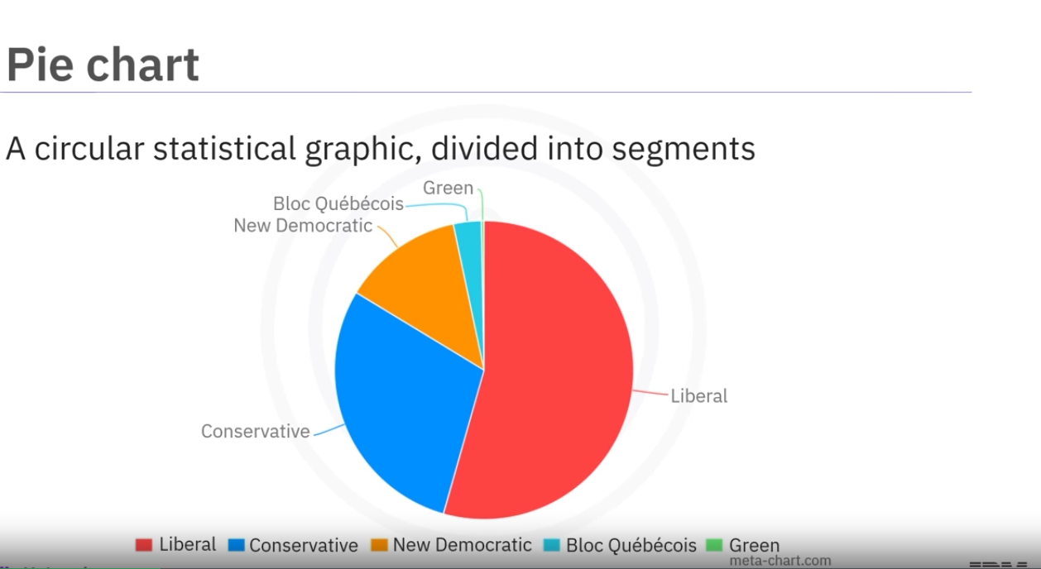

To illustrate numerical proportion

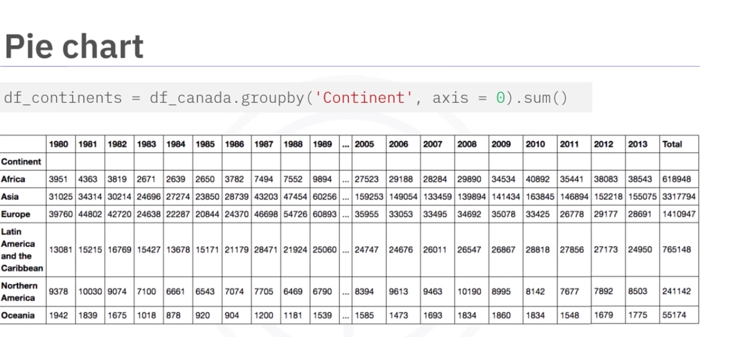

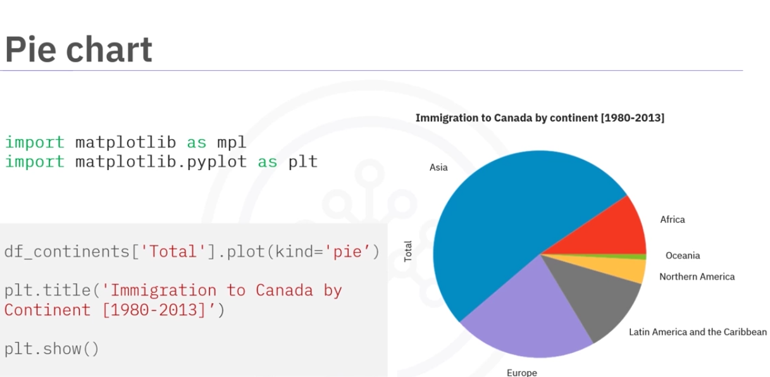

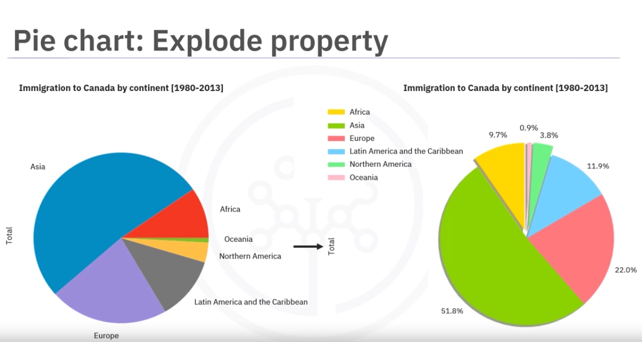

The explode property helps to emphasise on specific parts of the pie chart.

Pie charts are generally not considered accurate data consistently.Bar charts are significantly better.

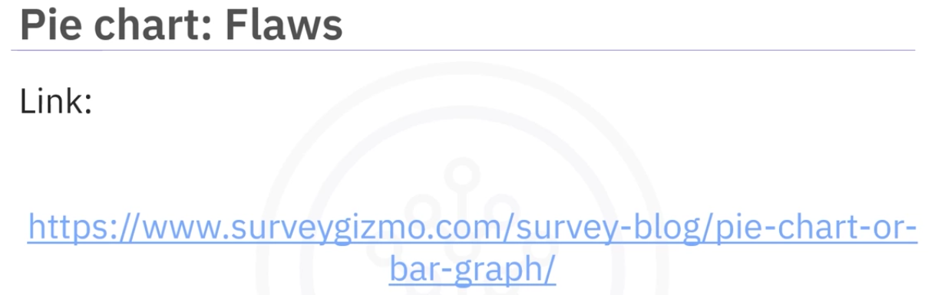

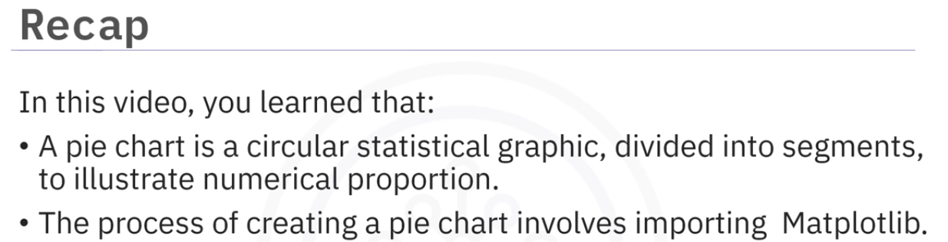

Box Plot

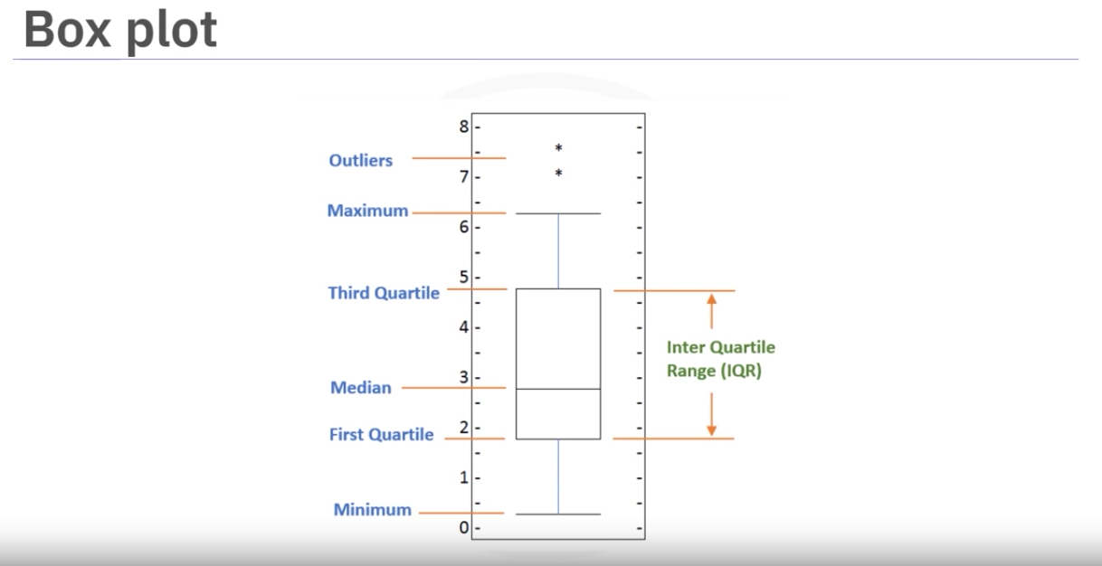

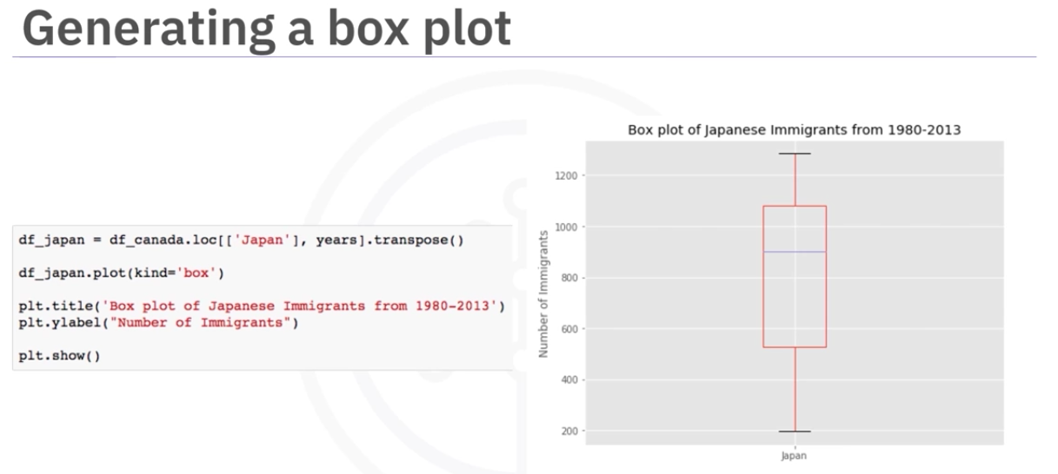

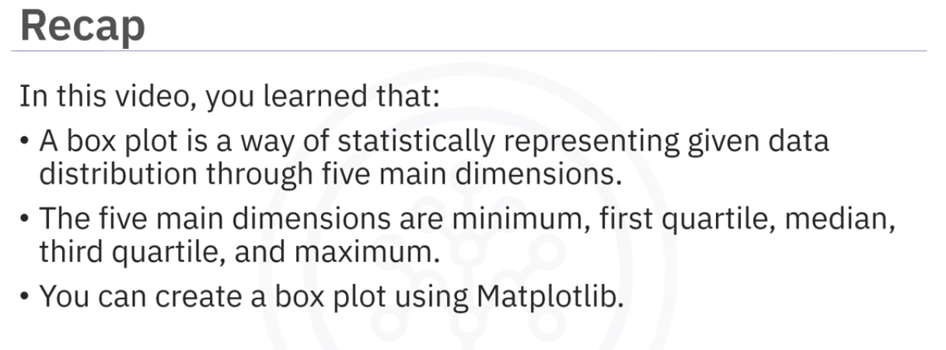

Scatter Plot

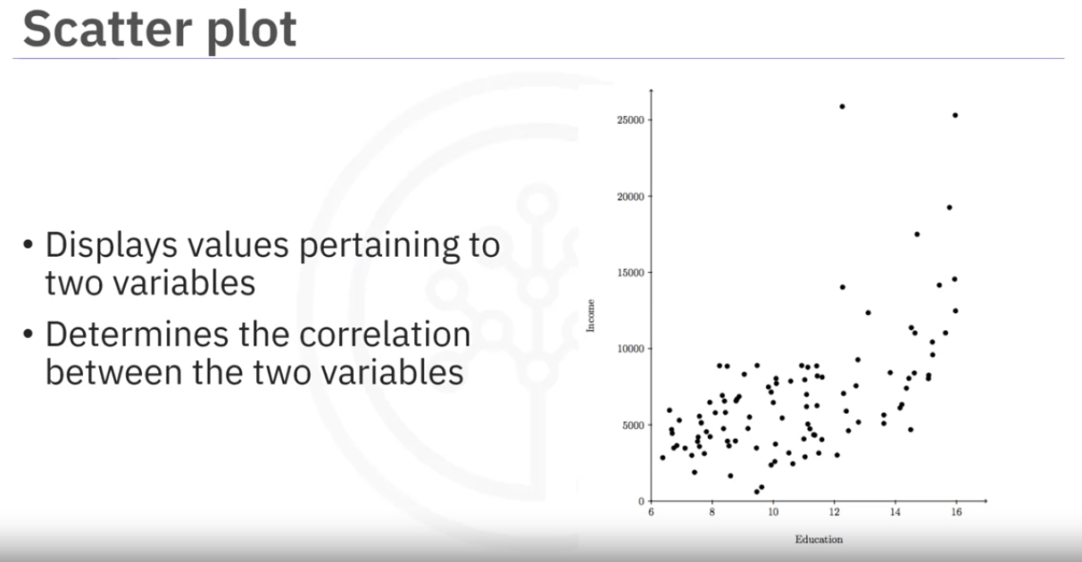

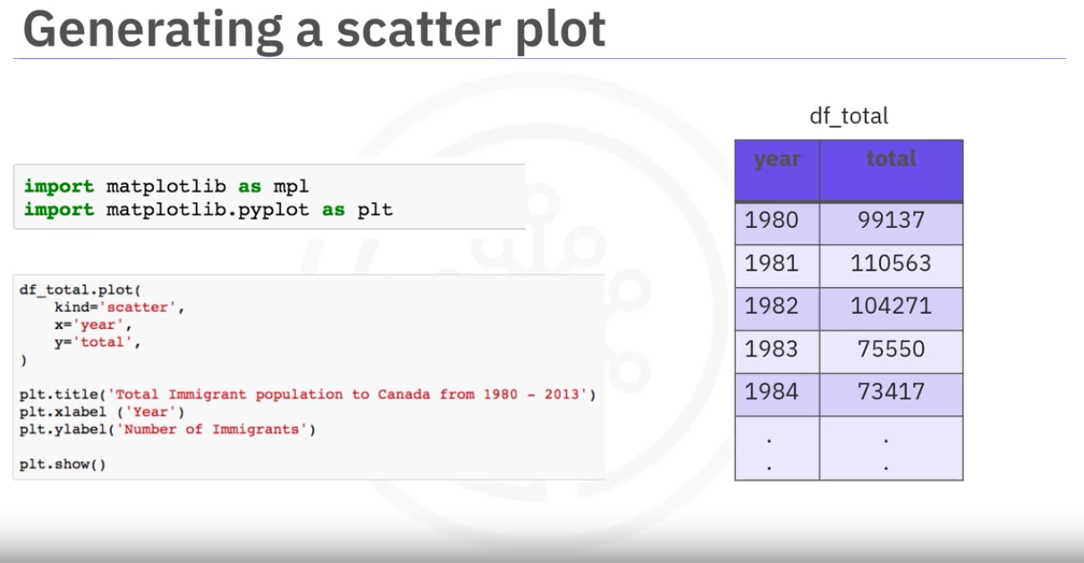

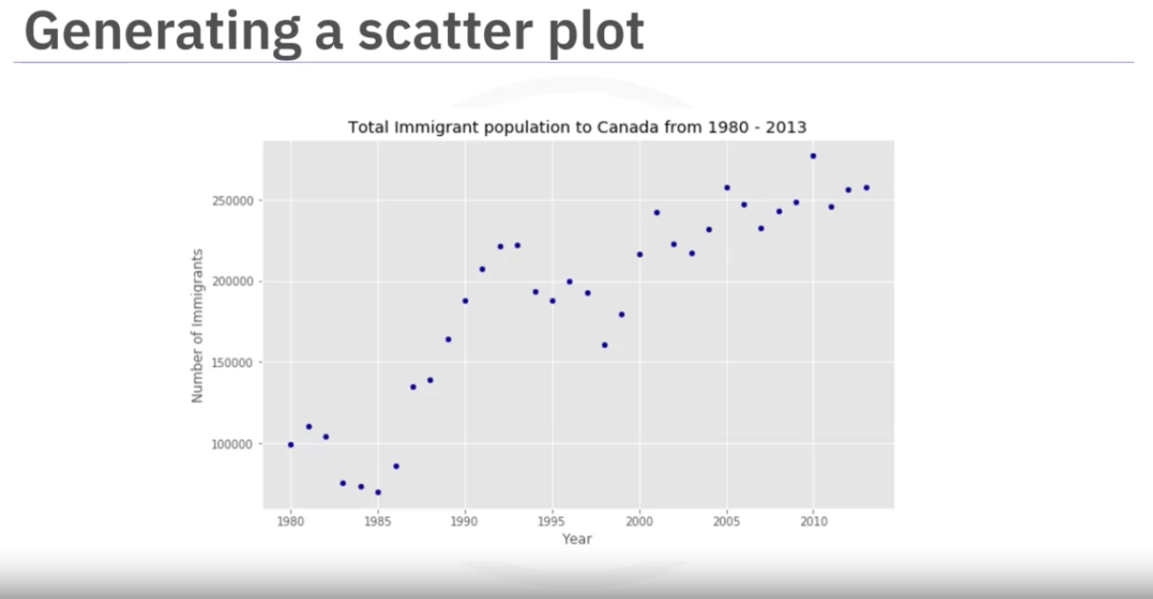

we can use different colors using c parameter

we can use the s paramter that represents any third variable from the dataframe Including total here for it cahnges the size of the markers based on the total in the next plot

Plotting with matplotlib

A general purpose comprehensive plotting library that provides a flexible interface for creating wide range of plots

Its pyplot module offers modules gives a convenient way to customize plots

we also use numpy as data source sometimes and supports mathematical functions

for tabular data we import pandas.

subplot helps to create a figure, canvas window and axes

It is where the plot appears.

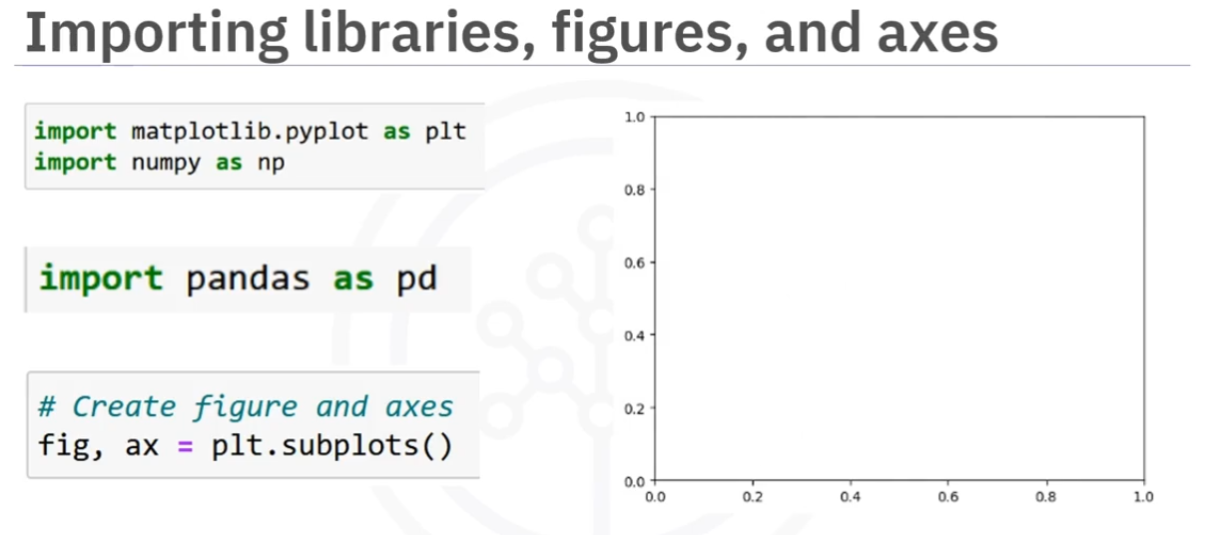

We can use the axes to plot the graphs.

The example show a line and scatter plots on some dummy data.

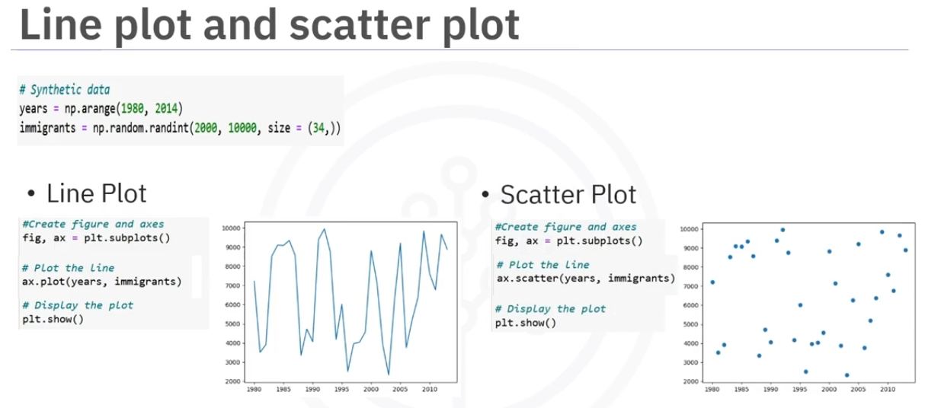

We can labels and title to the plt or ax

notice when setting the title and lables the methods are different for the plt and ax

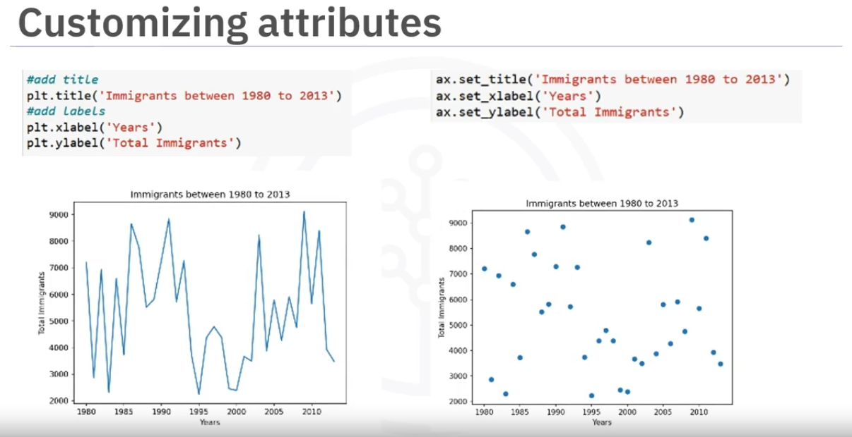

We can add xlim, ylim, add lengen and grid

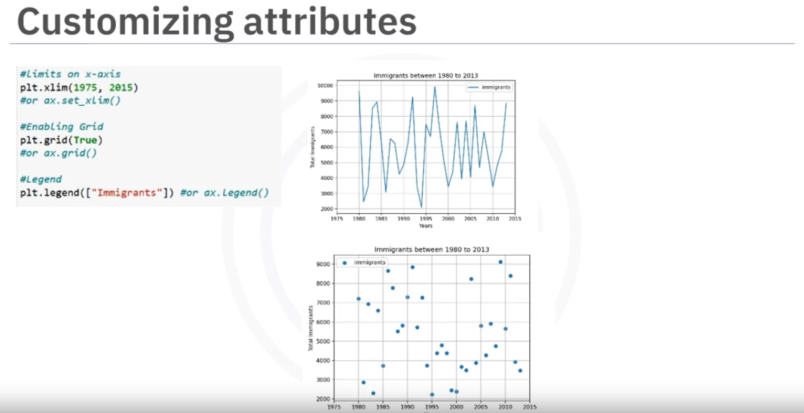

WE can change the line style, marker styles and color customization options on ax or plt

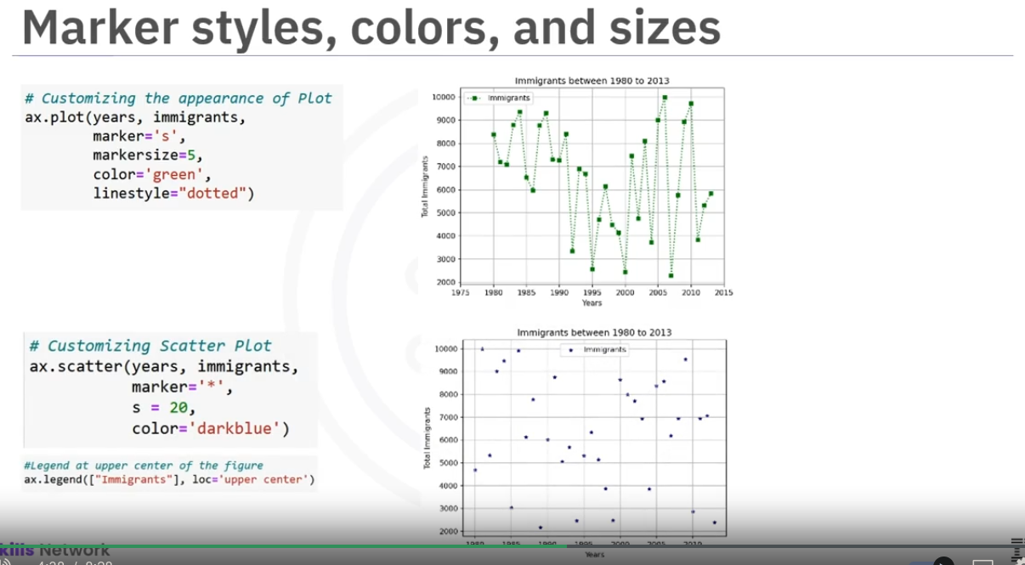

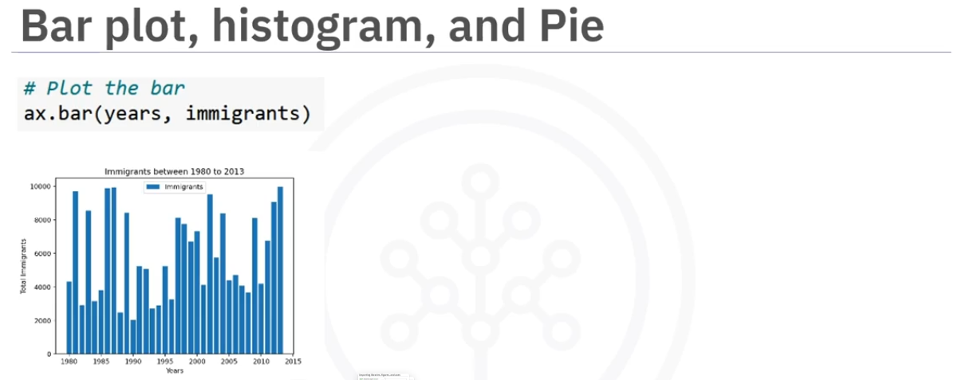

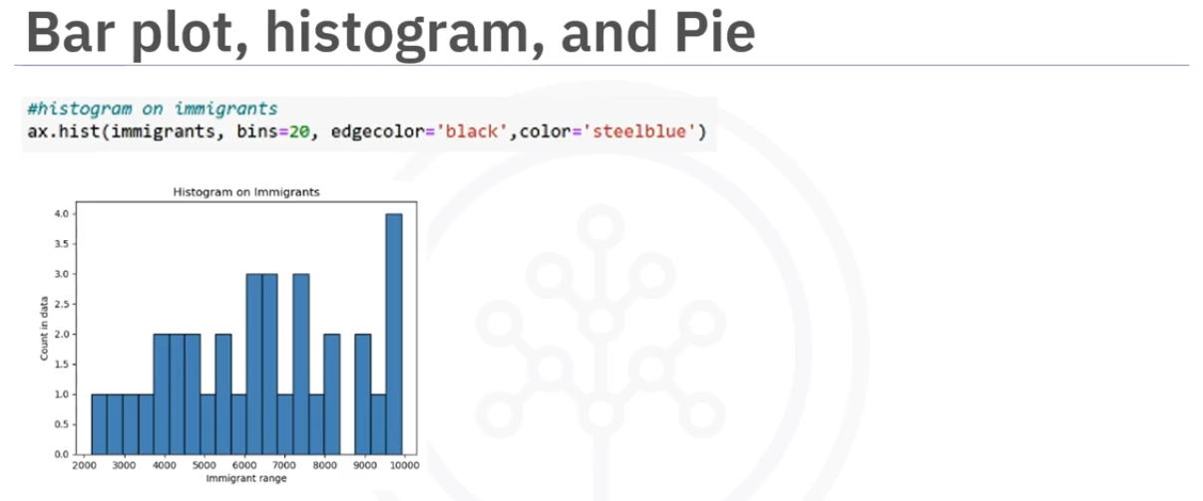

The autopct parameter in the pie chart displays the percentages corrected to one decimal point.

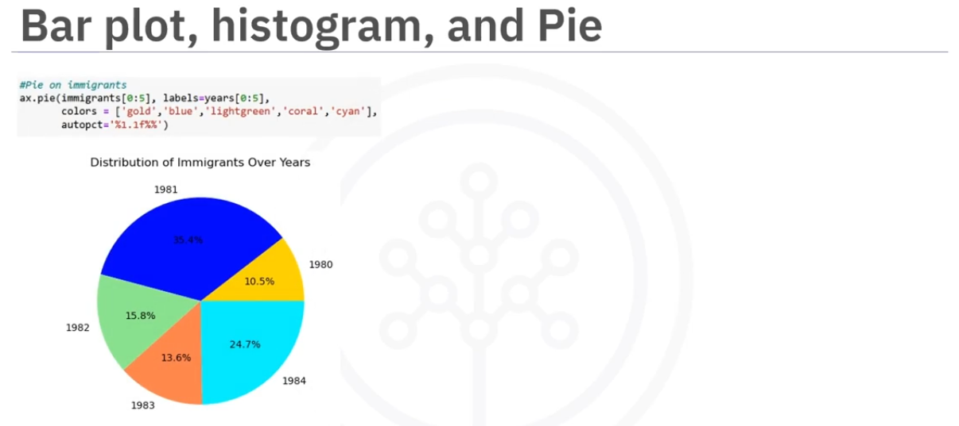

We can create more than one plot in a figure for this we have to provide number of rows and colums we want in the subplots function. We can optionally provide sharey property that shares y axis for all the graphs in the row,

now the axs is a list that has 2 axes for which we can add different plots. and set titles and labels.

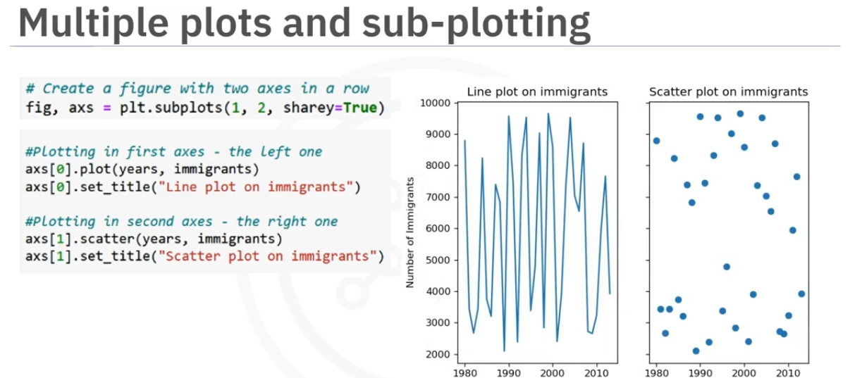

The alternate way is to use add subplot function on the fig object

Here we are creating a 2 by 2 figure that has differnt plots

We number the plots starting from 1.

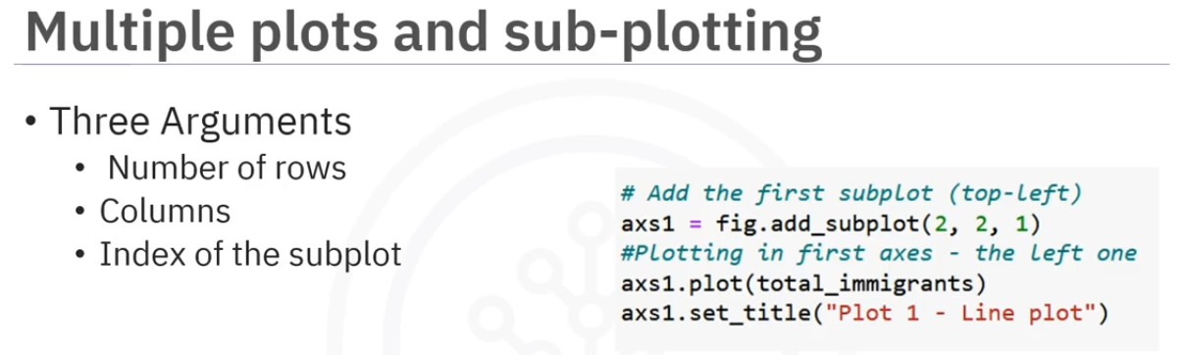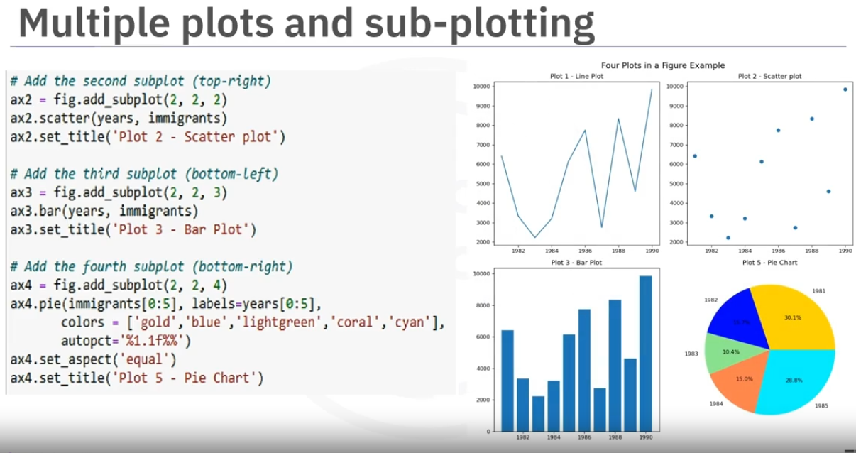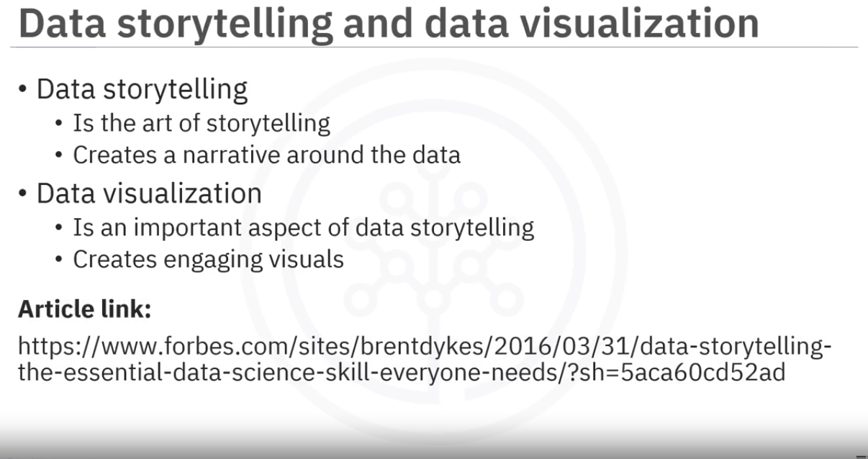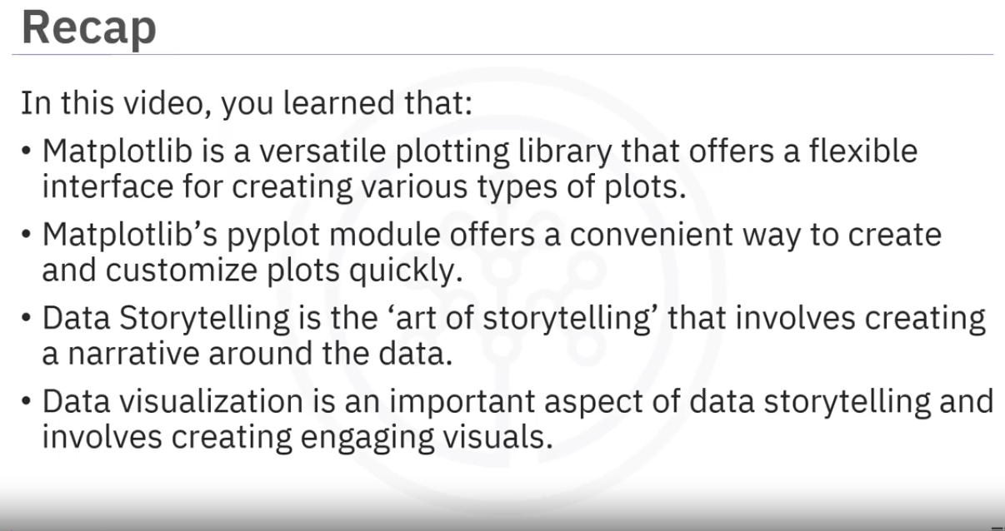

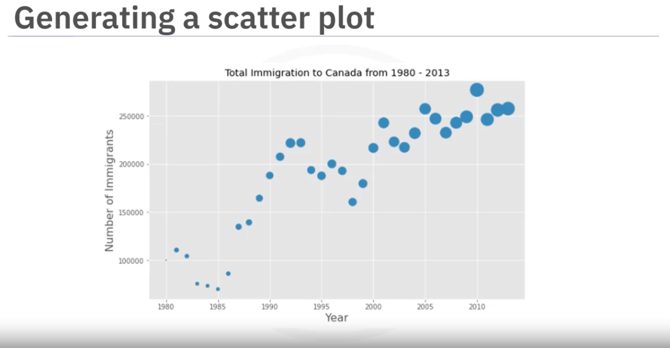

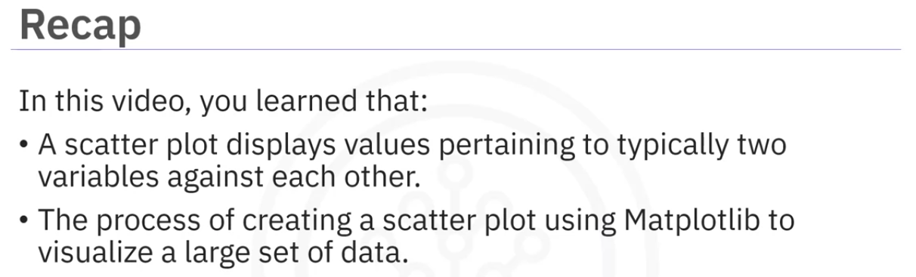

## Summary: Basic and Specialized Visualization Tools

Congratulations! You have completed this module. At this point in the course, you know:

A pie chart is a circular statistical graphic, divided into segments, to illustrate numerical proportion.

The process of creating a pie chart involves importing Matplotlib to represent a large set of data over a period of time.

A box plot is a way of statistically representing given data distribution through five main dimensions.

The five main dimensions are minimum, first quartile, median, third quartile, and maximum.

You can create a box plot using Matplotlib.

A scatter plot displays values pertaining to typically two variables against each other.

The process of creating a scatter plot involves importing Matplotlib to visualize a large set of data.

Matplotlib is a versatile plotting library that offers a flexible interface for creating various types of plots.

Matplotlib’s Pyplot module offers a convenient way to create and customize plots quickly.

Data Storytelling is the ‘art of storytelling’ that involves creating a narrative around the data.

Data visualization is an important aspect of data storytelling and involves creating engaging visuals.